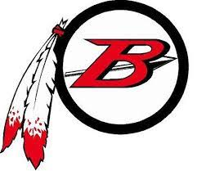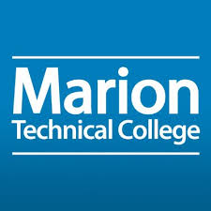

March 7th, 2023

In support of Ohio's College Credit Plus program, Marion Technical College (MTC) and Bucyrus City Schools (BCS) agree to continue a partnership for the academic year 2023/24 for the purpose of offering college­ level coursework to the students of Bucyrus City Schools.

This Memorandum of Understanding includes the following:

- BCS will maintain its current dual enrollment/CCP instructors and classes, as well as have the capacity to build new TAG/OTM courses in collaboration with MTC
- The partners will continue to streamline its registration process that will continue to limit workflow issues
- MTC and BCS will follow state laws and rules for acceptance into the CCP program.
- BCS will provide, via an official BCS transcript, evidence of students having completed courses through other IHEs to MTC for the purpose of prerequisite determination.
- BCS instructors will use MTC’s Canvas as the LMS system. MTC and BCS faculty will collaborate on the CANVAS course sites.
- BCS instructors will follow MTC’s syllabi, learning outcomes and grading scales for all courses

*MTC complies with The Higher Learning Commission and the Ohio Department of Higher Education when credentialing new high school staff to teach college level course work.

Marion Technical College will adhere to the default funding model as prescribed in the College Credit Plus legislation (Ohio Revised Code 3365.07). Textbooks are the responsibility of the school district.

Marion Technical College and Bucyrus City Schools will offer the following agreed TAG/OTM college courses for Fall 2023 and Spring 2024 at the Bucyrus High School location:

Fall 2023
- SOC1200, Sociology
- BIO1200, Human Biology
- POL1000, American Government *Tentative

Spring 2024:
- PSY1100, Intro to Psychology
- CRJ1500, Criminology

Marion Technical College and Bucyrus City Schools will partner to provide advising for all students interested in enrollment. This advising will increase students’ success by ensuring the best fit possible and communicating policies such as registration, add and drop dates for the 2023/24 calendar year. This will happen for courses located at BCS and for students taking courses at MTC.

The high school will handle any behavioral issues when the course is taught at the high school by a high school credentialed teacher. BCS will follow MTC’s academic misconduct policy for all College Credit Plus courses taken by BCS students.

This partnership will provide the continuing work to expand opportunities for students in central Ohio to prepare them for further education or a technically trained workforce career.

Callum Morris Robert A. Britton
Director of College Credit Plus Superintendent
Marion Technical College Bucyrus City Schools

